Web Technologies (CSC336) - Lab Mid Term
Name: Anber Tabassum
Registration No: FA24-BCS-125
Personal numbers: N = 25, BP = 625px, H = 175 (accent colour hsl (175, 70%, 45%)), K = 4
Task 1 - Mega-menu in the navbar
Screenshots
1280px
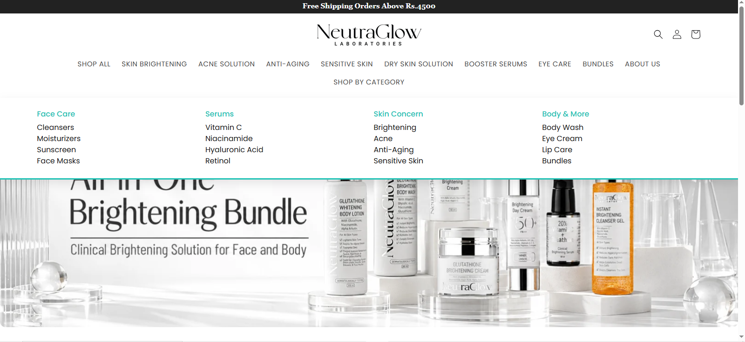
625px (BP)
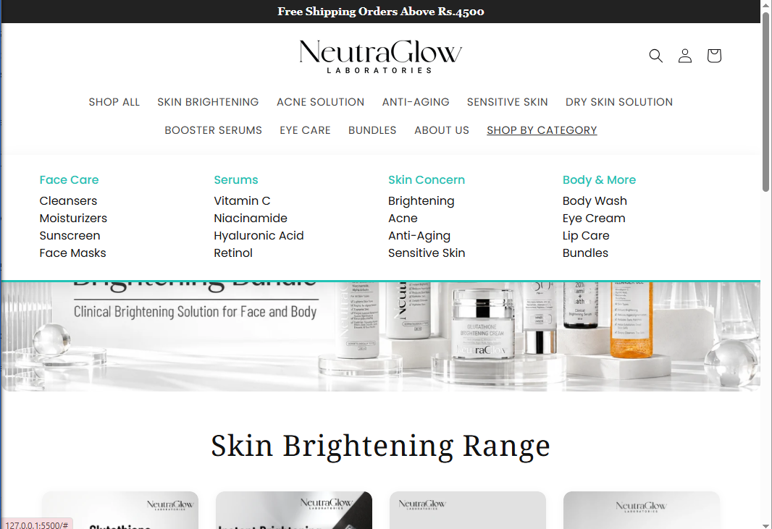
375px
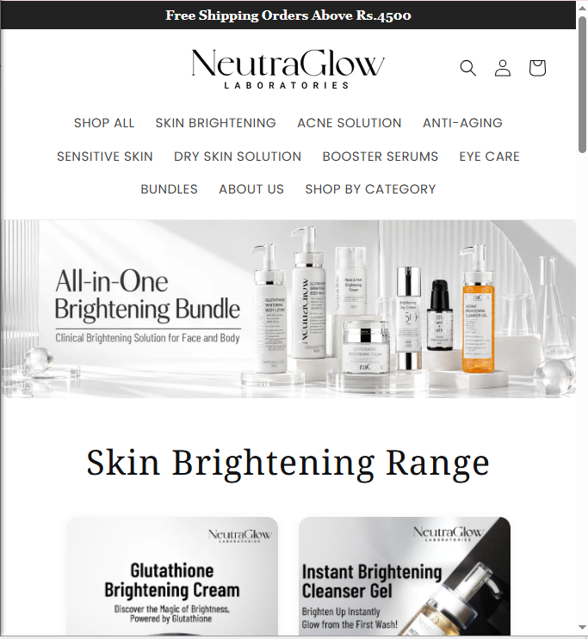
Code - index.html (navbar)
<nav class="navbar has-mega">
<input type="checkbox" id="menu-toggle" class="menu-togge">
<label for="menu-toggle" class="hamburger">&#9776;</label>

<ul class="navbar-nav">
<li class="nav-item"><a class="nav-link" href="#">SHOP ALL</a></li>
<li class="nav-item"><a class="nav-link" href="#">SKIN BRIGHTENING</a></li>
<li class="nav-item"><a class="nav-link" href="#">ACNE SOLUTION</a></li>
<li class="nav-item"><a class="nav-link" href="#">ANTI-AGING</a></li>
<li class="nav-item"><a class="nav-link" href="#">SENSITIVE SKIN</a></li>
<li class="nav-item"><a class="nav-link" href="#">DRY SKIN SOLUTION</a></li>
<li class="nav-item"><a class="nav-link" href="#">BOOSTER SERUMS</a></li>
<li class="nav-item"><a class="nav-link" href="#">EYE CARE</a></li>
<li class="nav-item"><a class="nav-link" href="#">BUNDLES</a></li>
<li class="nav-item"><a class="nav-link" href="#">ABOUT US</a></li>

<li class="nav-item mega">
<a class="nav-link" href="#">SHOP BY CATEGORY</a>

<!-- BP and wider: panel -->
<div class="mega-panel">
<div>
<h6>Face Care</h6>
<ul>
<li><a href="#">Cleansers</a></li>
<li><a href="#">Moisturizers</a></li>
<li><a href="#">Sunscreen</a></li>
<li><a href="#">Face Masks</a></li>
</ul>
</div>
<div>
<h6>Serums</h6>
<ul>
<li><a href="#">Vitamin C</a></li>
<li><a href="#">Niacinamide</a></li>
<li><a href="#">Hyaluronic Acid</a></li>
<li><a href="#">Retinol</a></li>
</ul>
</div>
<div>
<h6>Skin Concern</h6>
<ul>
<li><a href="#">Brightening</a></li>
<li><a href="#">Acne</a></li>
<li><a href="#">Anti-Aging</a></li>
<li><a href="#">Sensitive Skin</a></li>
</ul>
</div>
<div>
<h6>Body &amp; More</h6>
<ul>
<li><a href="#">Body Wash</a></li>
<li><a href="#">Eye Cream</a></li>
<li><a href="#">Lip Care</a></li>
<li><a href="#">Bundles</a></li>
</ul>
</div>
</div>

<!-- below BP: accordion -->
<div class="mega-mobile">
<details>
<summary>Face Care</summary>
<ul>
<li><a href="#">Cleansers</a></li>
<li><a href="#">Moisturizers</a></li>
<li><a href="#">Sunscreen</a></li>
<li><a href="#">Face Masks</a></li>
</ul>
</details>
<details>
<summary>Serums</summary>
<ul>
<li><a href="#">Vitamin C</a></li>
<li><a href="#">Niacinamide</a></li>
<li><a href="#">Hyaluronic Acid</a></li>
<li><a href="#">Retinol</a></li>
</ul>
</details>
<details>
<summary>Skin Concern</summary>
<ul>
<li><a href="#">Brightening</a></li>
<li><a href="#">Acne</a></li>
<li><a href="#">Anti-Aging</a></li>
<li><a href="#">Sensitive Skin</a></li>
</ul>
</details>
<details>
<summary>Body &amp; More</summary>
<ul>
<li><a href="#">Body Wash</a></li>
<li><a href="#">Eye Cream</a></li>
<li><a href="#">Lip Care</a></li>
<li><a href="#">Bundles</a></li>
</ul>
</details>
</div>
</li>
</ul>
</nav>
Code - style.css
:root {
--accent: hsl(175, 70%, 45%);
}

header {
position: relative;
z-index: 1000;
border-bottom: 1px solid #eee;
padding: 15px 5%;
}

/* ---------- Mega menu (Task 1) ---------- */
.navbar.has-mega {
position: static; /* panel is measured from the header, so it is full width */
overflow: visible; /* otherwise the panel would be cut off */
}
.has-mega .navbar-nav {
--bs-nav-link-padding-x: 12px;
}
.menu-toggle {
position: absolute;
opacity: 0;
pointer-events: none;
}
.hamburger {
display: none;
}
.mega {
position: static;
}
.mega-panel {
display: none;
position: absolute; /* does not push the page down */
left: 0;
right: 0;
top: 100%;
padding: 25px 5%;
background: white;
border-bottom: 3px solid var(--accent);
box-shadow: 0 8px 20px rgba(0, 0, 0, 0.1);
grid-template-columns: repeat(4, 1fr); /* K = 4 columns */
gap: 20px;
}
/* invisible bridge: pointer can travel from the menu item to the panel */
.mega-panel::before {
content: "";
position: absolute;
left: 0;
right: 0;
top: -40px;
height: 40px;
}
.mega-panel h6 {
color: var(--accent);
}
.mega-panel ul,
.mega-mobile ul {
list-style: none;
padding: 0;
}
.mega-panel a:hover,
.mega-mobile a:hover {
text-decoration: underline;
}
.mega-mobile summary {
padding: 8px 0;
cursor: pointer;
}

/* BP = 600 + 25 = 625px and wider */
@media (min-width: 625px) {
.has-mega .navbar-nav {
flex-direction: row;
flex-wrap: wrap;
justify-content: center;
}
.mega-mobile {
display: none;
}
.mega:hover .mega-panel,
.mega:focus-within .mega-panel {
display: grid;
}
}

/* below BP: hamburger + accordion */
@media (max-width: 624px) {
.hamburger {
display: block;
margin-left: auto;
padding: 4px 12px;
border: 1px solid #ccc;
border-radius: 6px;
font-size: 22px;
cursor: pointer;
}
.has-mega .navbar-nav {
display: none;
width: 100%;
}
.menu-toggle:checked ~ .navbar-nav {
display: flex;
}
.mega > .nav-link,
.mega-panel {
display: none;
}
.mega-mobile {
padding: 0 12px;
}}
TASK 2
SCREENSHORT
1280px
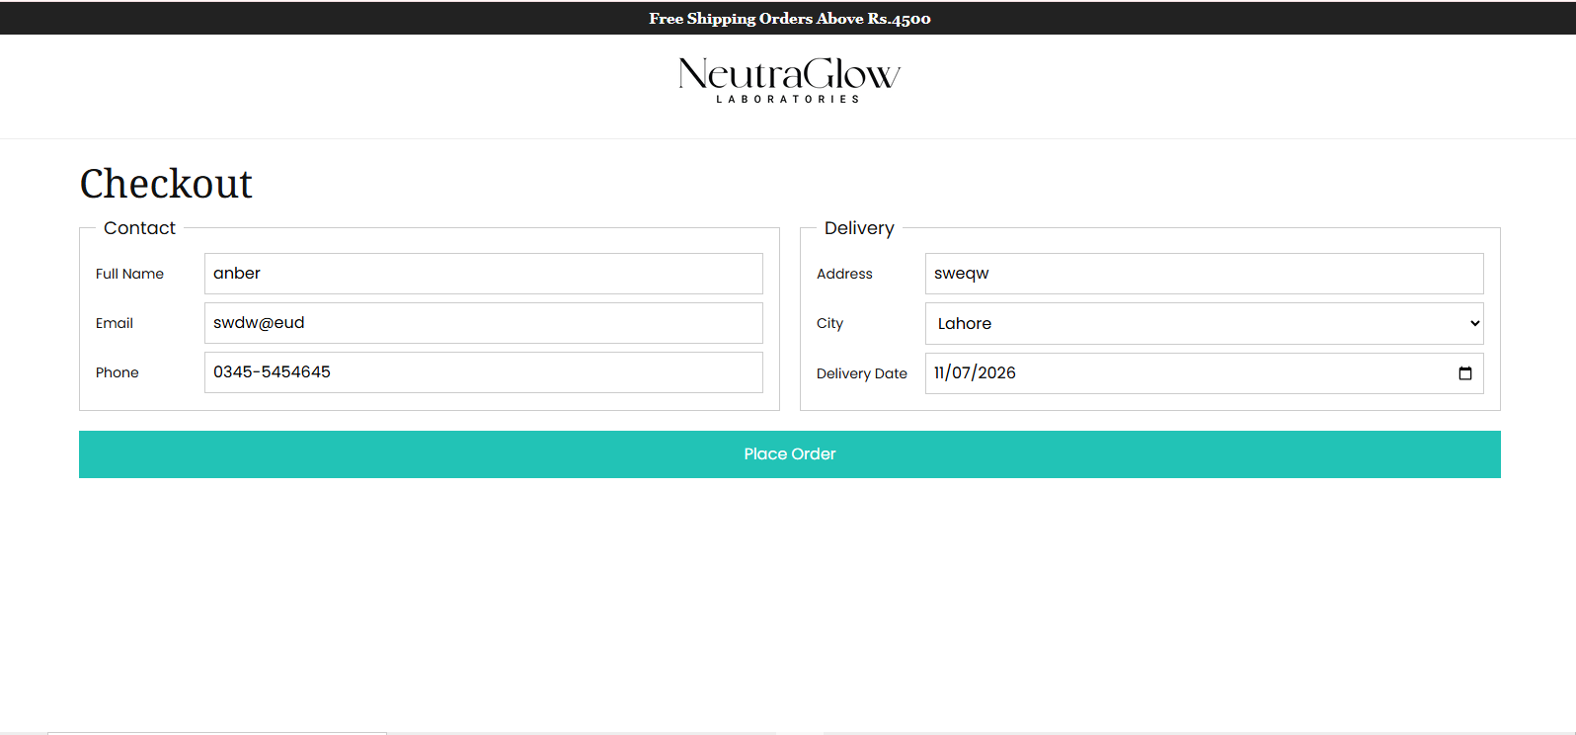
625px (BP)
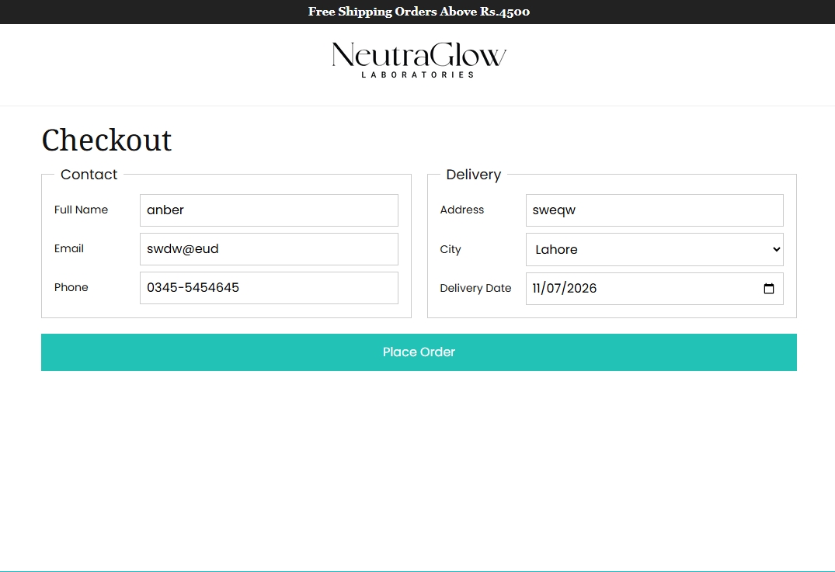
375px
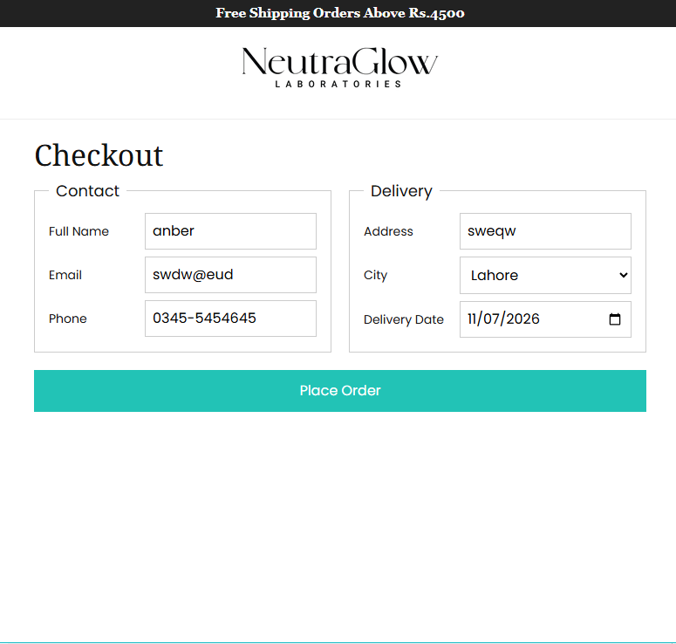
Checkout.html
<!DOCTYPE html>
<html lang="en">
<head>
<meta charset="UTF-8">
<meta name="viewport" content="width=device-width, initial-scale=1">
<title>Checkout - NeutraGlow</title>
<link href="https://cdn.jsdelivr.net/npm/bootstrap@5.3.3/dist/css/bootstrap.min.css" rel="stylesheet">
<link href="https://fonts.googleapis.com/css2?family=Noto+Serif&family=Poppins:wght@400;500&display=swap" rel="stylesheet">
<link href="style.css" rel="stylesheet">
</head>
<body>

<div class="topbar">Free Shipping Orders Above Rs.4500</div>

<header>
<div class="header-top">
<div></div>
<a href="index.html" class="logo"><img src="images/logo.png" alt="NeutraGlow Laboratories"></a>
<div></div>
</div>
</header>

<main class="checkout">
<h1>Checkout</h1>

<form action="#">
<div class="fieldsets">

<fieldset>
<legend>Contact</legend>

<label for="name">Full Name</label>
<input type="text" id="name" required>
<span class="msg">Please enter your name.</span>

<label for="email">Email</label>
<input type="email" id="email" required>
<span class="msg">Enter a valid email.</span>

<label for="phone">Phone</label>
<input type="tel" id="phone" pattern="03[0-9]{2}-[0-9]{7}" placeholder="03XX-XXXXXXX" required>
<span class="msg">Format: 03XX-XXXXXXX</span>
</fieldset>

<fieldset>
<legend>Delivery</legend>

<label for="address">Address</label>
<input type="text" id="address" required>
<span class="msg">Please enter your address.</span>

<label for="city">City</label>
<select id="city" required>
<option value="">Select city</option>
<option>Lahore</option>
<option>Karachi</option>
<option>Islamabad</option>
</select>
<span class="msg">Please choose a city.</span>

<!-- min = exam date, max = exam date + N (25) days -->
<label for="date">Delivery Date</label>
<input type="date" id="date" min="2026-10-29" max="2026-11-23" required>
<span class="msg">Pick a date within 25 days of the exam date.</span>
</fieldset>

</div>

<button type="submit" class="checkout-btn">Place Order</button>
</form>
</main>

</body>
</html>
Style.css
/* ---------- Checkout (Task 2) ---------- */
.checkout {
padding: 20px 5% 0;
}
.fieldsets {
display: grid;
grid-template-columns: 1fr;
gap: 20px;
}
fieldset {
display: grid;
grid-template-columns: 1fr; /* below BP: label above input */
gap: 8px;
align-content: start;
min-width: 0;
padding: 12px 16px 16px;
border: 1px solid #ccc;
}
legend {
float: none;
width: auto;
margin-bottom: 0;
padding: 0 8px;
font-size: 18px;
}
fieldset label {
font-size: 14px;
}
fieldset input,
fieldset select {
width: 100%;
min-width: 0;
padding: 8px;
border: 1px solid #ccc;
}
.msg {
display: none;
color: red;
font-size: 13px;
}
/* only after the user has touched the field */
fieldset input:user-invalid,
fieldset select:user-invalid {
border-color: red;
box-shadow: 0 0 0 1px red;
}
fieldset input:user-invalid + .msg,
fieldset select:user-invalid + .msg {
display: block;
}
.checkout-btn {
width: 100%;
margin-top: 20px;
padding: 12px;
border: none;
background: var(--accent);
color: white;
font-size: 16px;
}

/* BP = 625px and wider: side by side, labels in a left column */
@media (min-width: 625px) {
.fieldsets {
grid-template-columns: 1fr 1fr;
}
fieldset {
grid-template-columns: 100px 1fr;
gap: 8px 10px;
}
fieldset label {
align-self: center;
}
.msg {
grid-column: 2;
}
}
TASK 3

